Triakis Octahedron

Definition
# Source: AI Source: Provided by: [Data Path: Persons Table -> ID Column: 1, Name_En Column: Motasem Essam] -> From: [ChatGPT] on [7/25/2026]
A Triakis Octahedron is a convex Catalan solid formed by attaching a triangular pyramid to each of the eight faces of a regular octahedron.
It has 24 congruent isosceles triangular faces, 36 edges, and 14 vertices.
It is also known as a Trigon Trisoctahedron or Trisoctahedron. It is the dual polyhedron of the Truncated Cube, an Archimedean solid.

Simple Definition
# Source: AI Source: Provided by: [Data Path: Persons Table -> ID Column: 1, Name_En Column: Motasem Essam] -> From: [ChatGPT] on [7/25/2026]
A Triakis Octahedron looks like a regular octahedron with eight triangular pyramids attached, one to each triangular face. The resulting solid has 24 triangular faces and a pointed, faceted appearance.
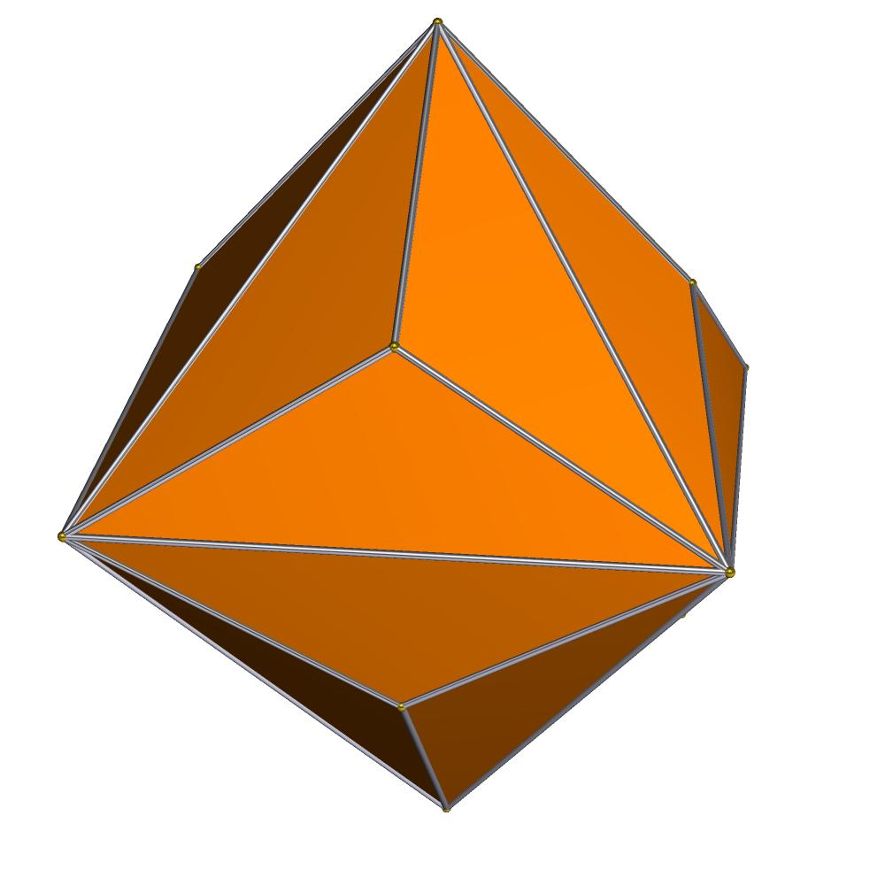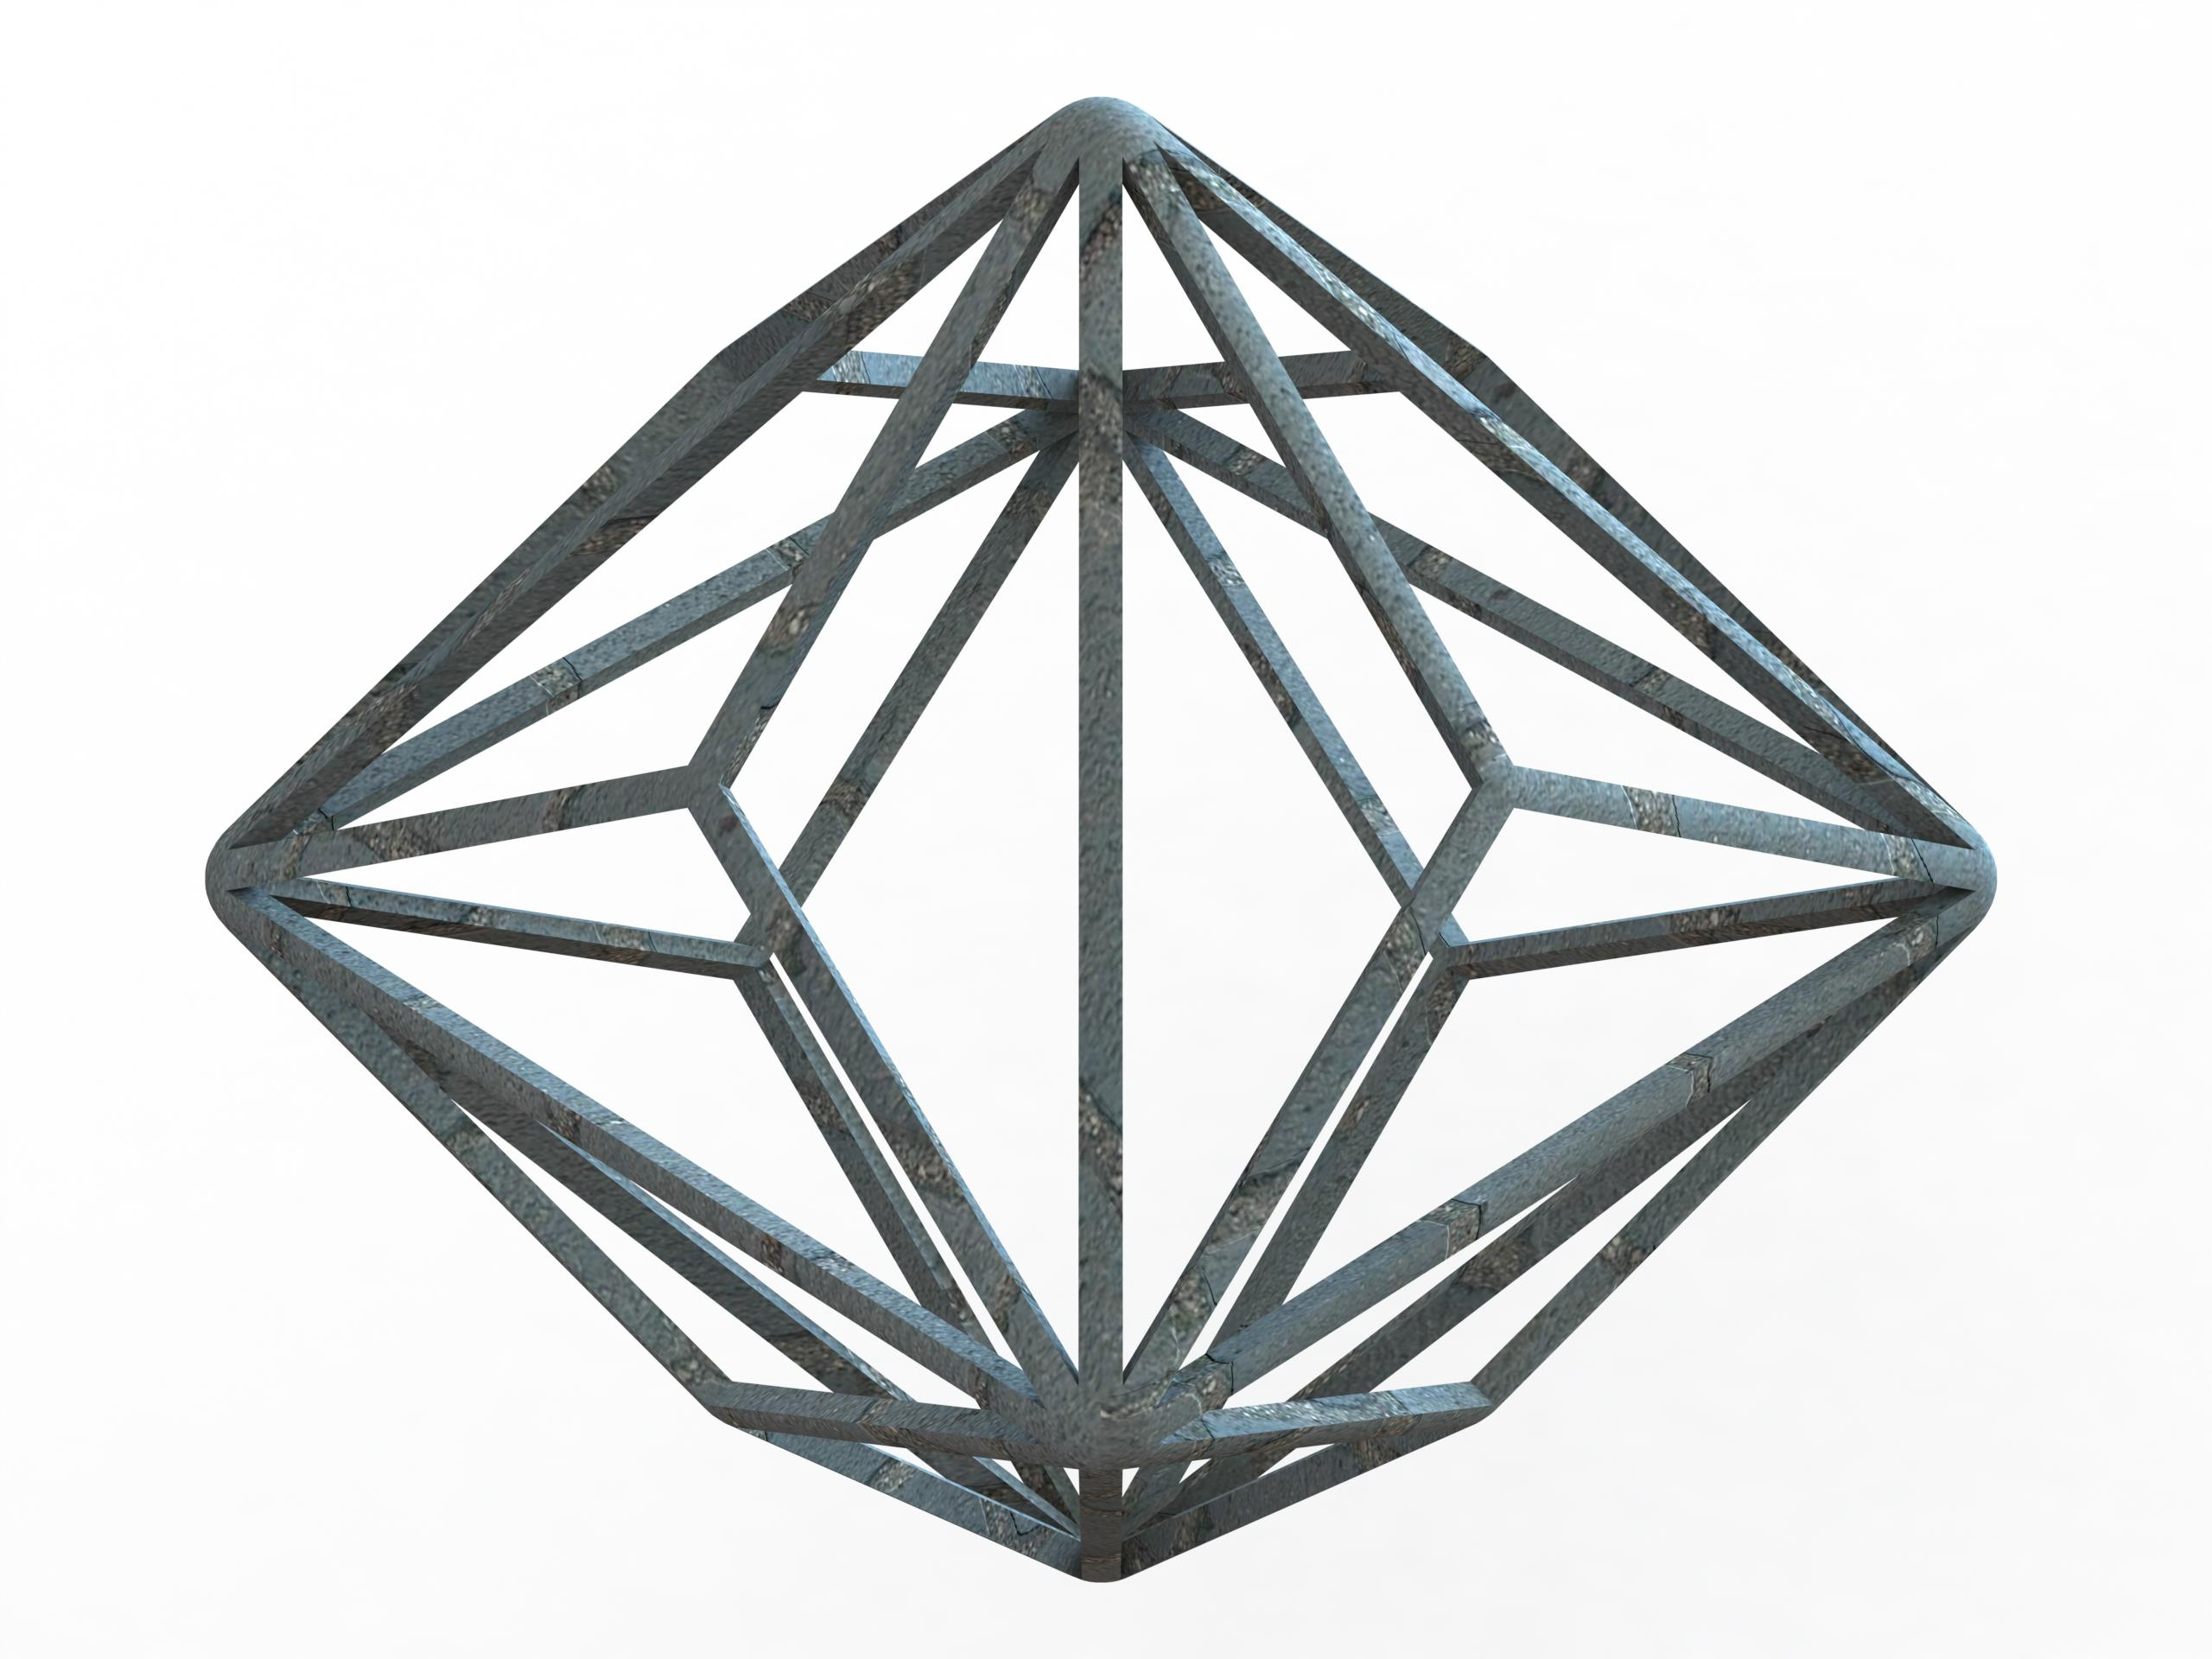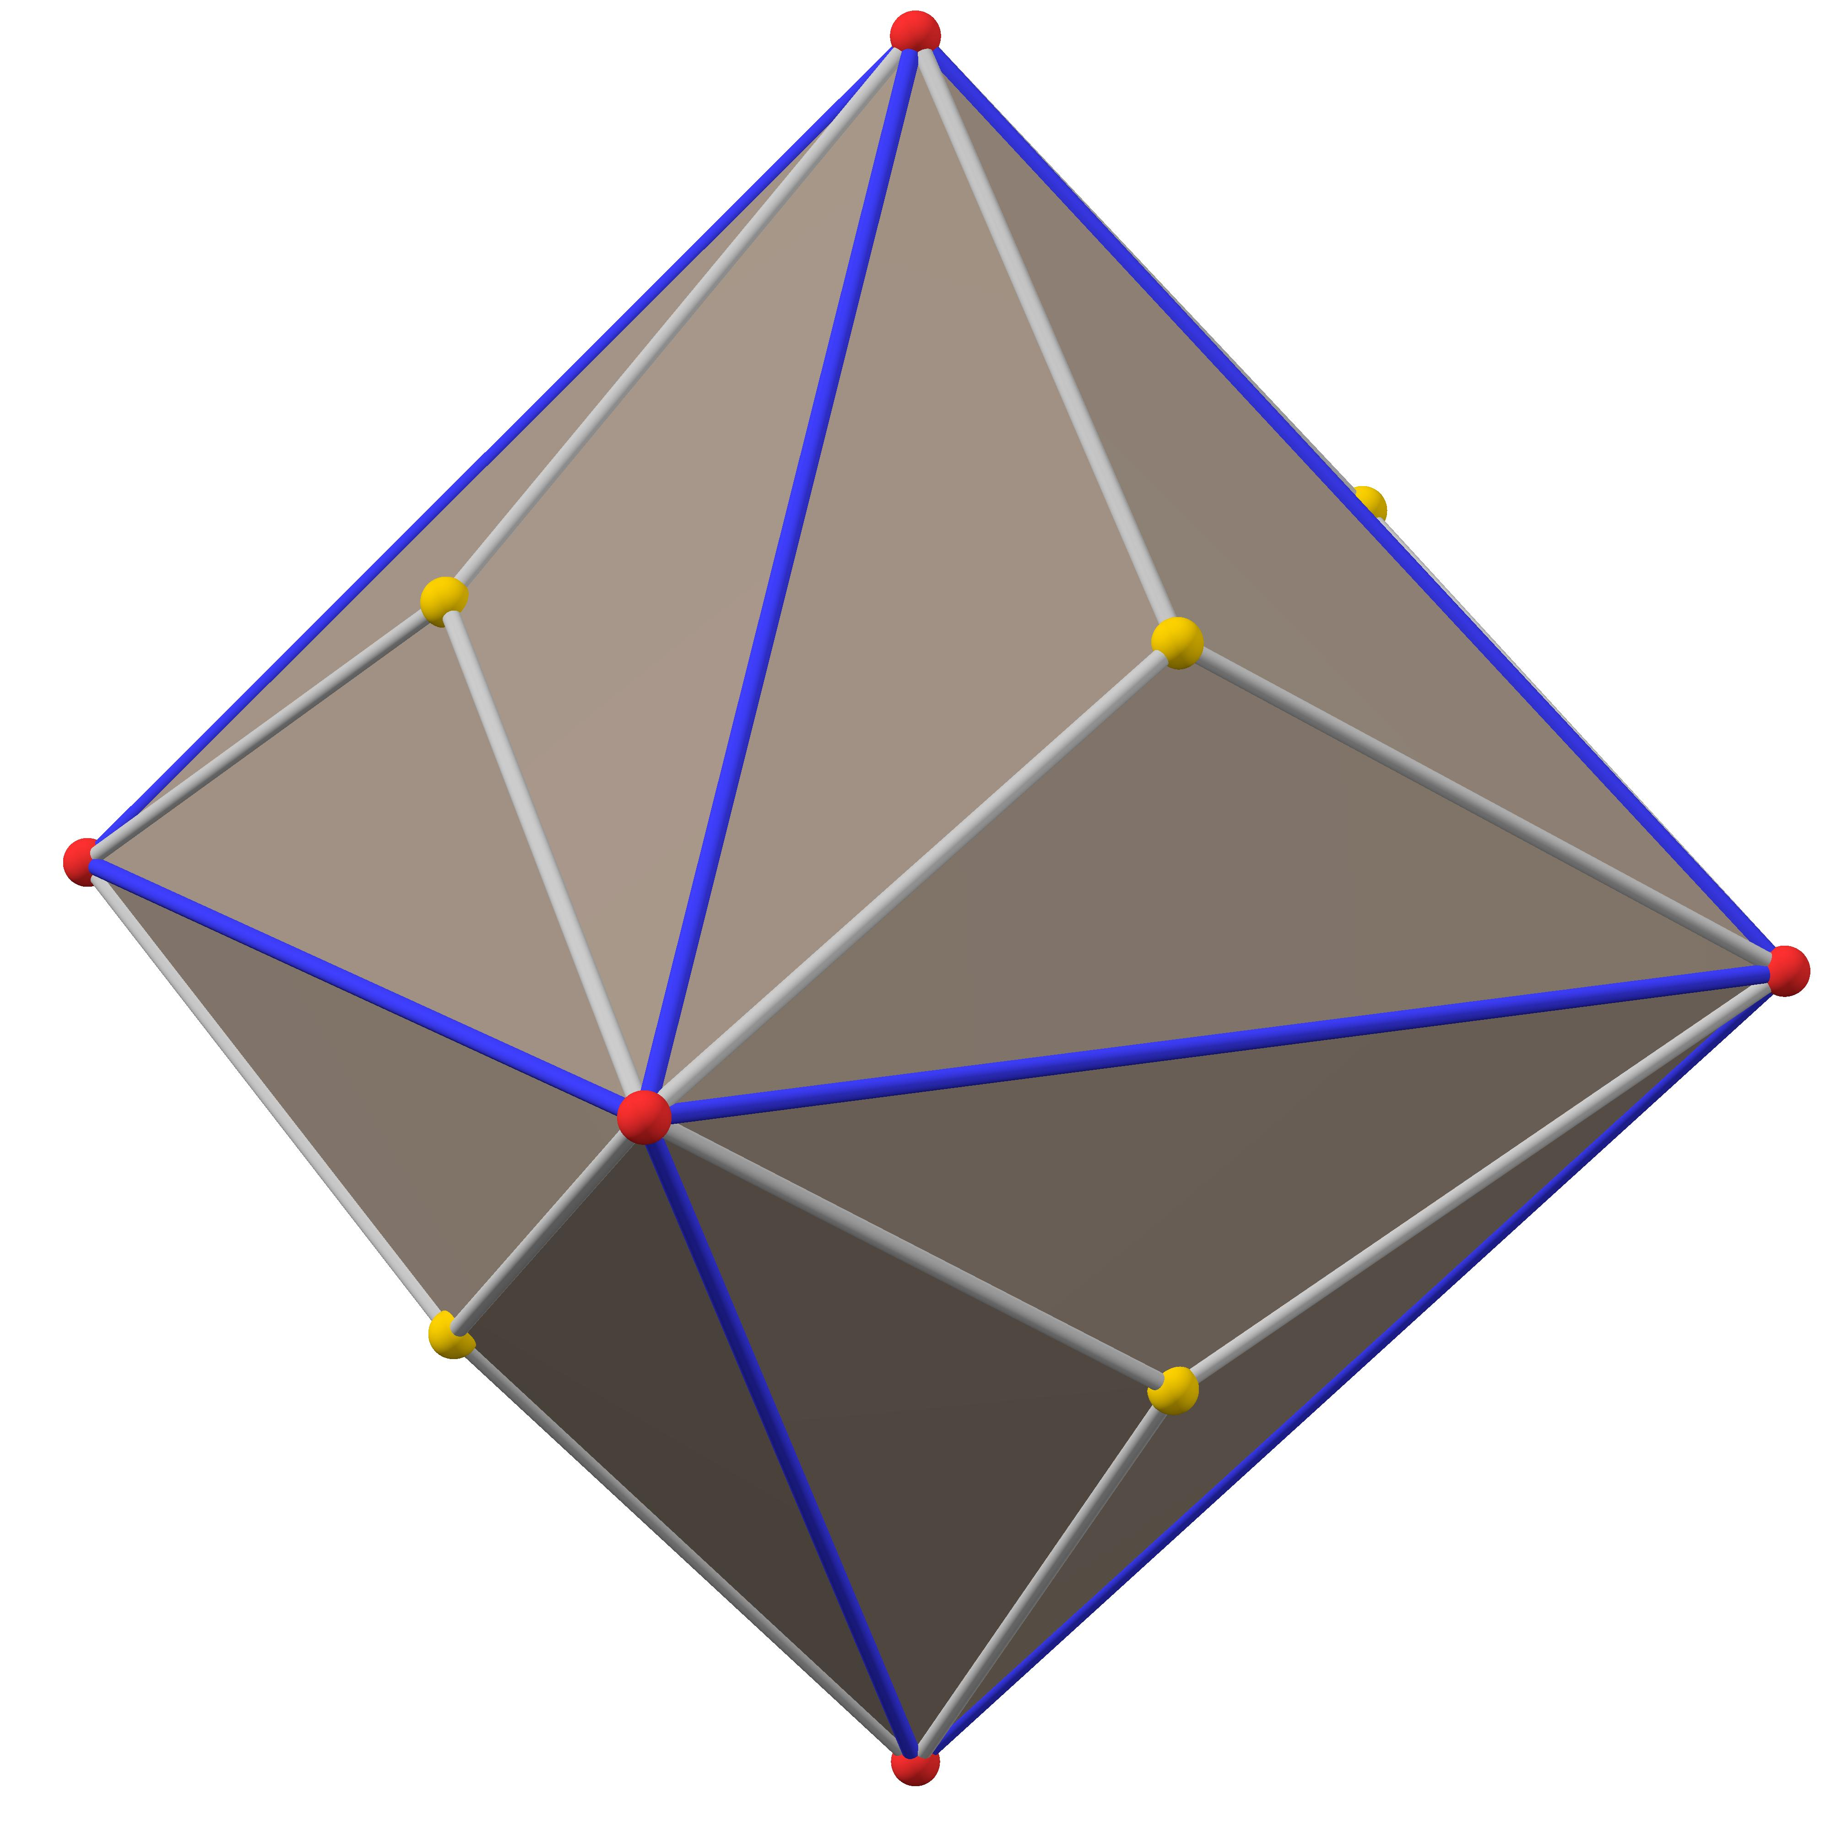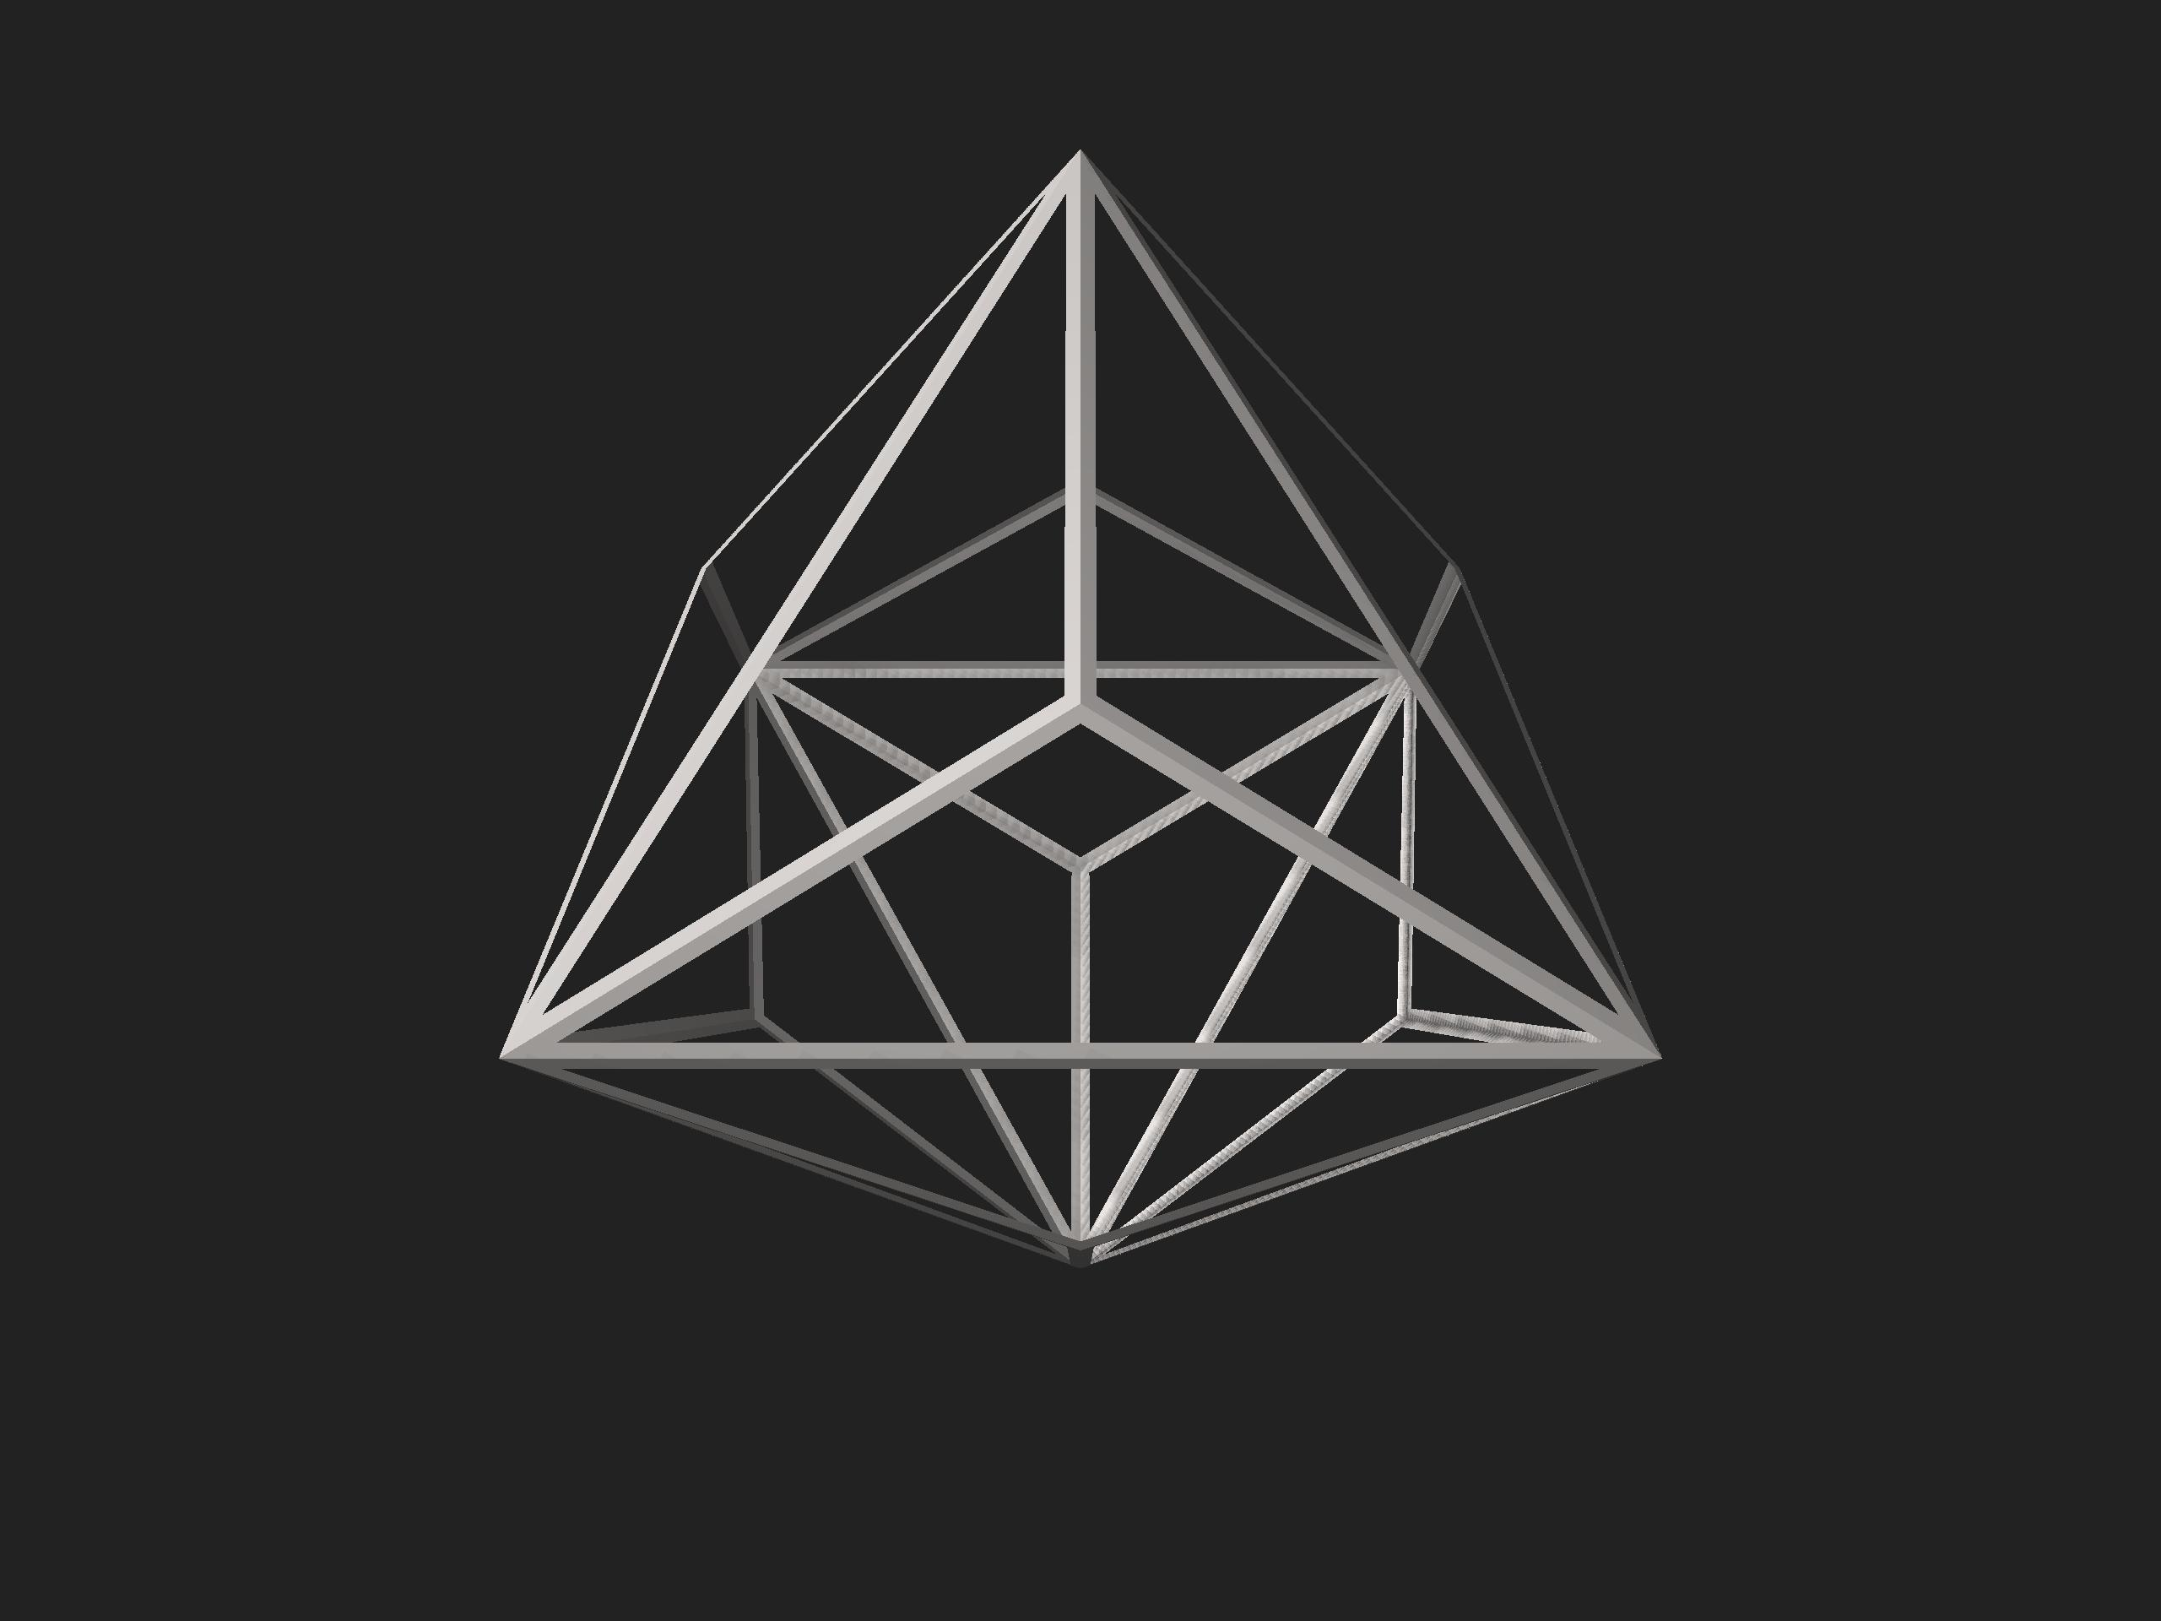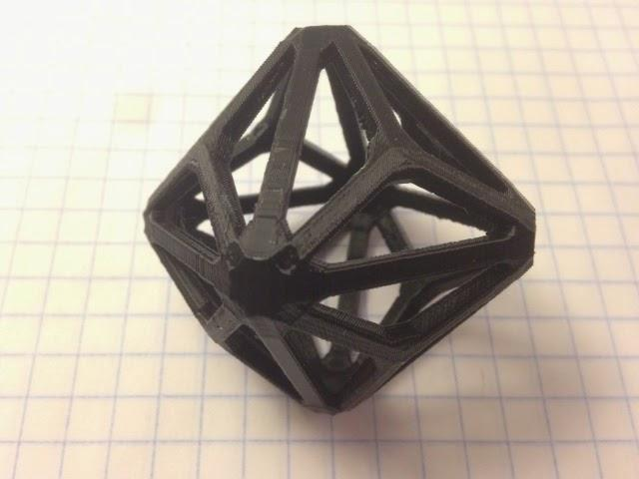

Geometric Structure
# Source: AI Source: Provided by: [Data Path: Persons Table -> ID Column: 1, Name_En Column: Motasem Essam] -> From: [ChatGPT] on [7/25/2026]
- It is based on a regular octahedron.
- Eight triangular pyramids are attached, one to each original triangular face.
- Each original triangular face is divided into three smaller triangular faces.
- The resulting solid has 24 congruent isosceles triangles.
- It is convex and has full octahedral symmetry.
This construction is an example of a polyhedral operation called a kleetope.

Face Structure
# Source: AI Source: Provided by: [Data Path: Persons Table -> ID Column: 1, Name_En Column: Motasem Essam] -> From: [ChatGPT] on [7/25/2026]
The Triakis Octahedron has:
- 24 faces in total.
- All faces are congruent isosceles triangles.
- Each triangular face has two equal shorter edges and one longer edge.
- The two shorter edges form the equal sides, while the longer edge forms the base.

Face angles
# Source: AI Source: Provided by: [Data Path: Persons Table -> ID Column: 1, Name_En Column: Motasem Essam] -> From: [ChatGPT] on [7/25/2026]
The approximate interior angles of each triangular face are:
- One larger angle: ${117.20}^{°}$.
- Two equal smaller angles: ${31.40}^{°}$ each.
$${117.20}^{°}+{31.40}^{°}+{31.40}^{°}={180}^{°}$$

Edge Structure
# Source: AI Source: Provided by: [Data Path: Persons Table -> ID Column: 1, Name_En Column: Motasem Essam] -> From: [ChatGPT] on [7/25/2026]
The Triakis Octahedron has 36 edges, divided into two groups:
- 24 shorter edges.
- 12 longer edges.
The shorter edges connect the eight pyramid apices to the original octahedron vertices. The longer edges correspond to the edges of the original octahedron.

Edge-length ratio
# Source: AI Source: Provided by: [Data Path: Persons Table -> ID Column: 1, Name_En Column: Motasem Essam] -> From: [ChatGPT] on [7/25/2026]
Let $s$ represent the shorter edge and $L$ the longer edge.
$$\frac{s}{L}=2-\sqrt{2}$$
Approximately:
$$\frac{s}{L}≈0.586$$
Therefore:
$$L≈1.707s$$

Vertex Structure
# Source: AI Source: Provided by: [Data Path: Persons Table -> ID Column: 1, Name_En Column: Motasem Essam] -> From: [ChatGPT] on [7/25/2026]
The Triakis Octahedron has 14 vertices, divided into two groups:
- 8 vertices of degree 3: Three triangular faces meet at each of these vertices. They are the apices of the eight attached pyramids.
- 6 vertices of degree 8: Eight triangular faces meet at each of these vertices. They correspond to the six original vertices of the octahedron.

Mathematical Properties
# Source: AI Source: Provided by: [Data Path: Persons Table -> ID Column: 1, Name_En Column: Motasem Essam] -> From: [ChatGPT] on [7/25/2026]
24
Faces
36
Edges
14
Vertices
147.35°
Dihedral angle (approximately)
Euler's formula
$$V-E+F=2$$
$$14-36+24=2$$
The Triakis Octahedron satisfies Euler's polyhedron formula.

Dihedral angle
# Source: AI Source: Provided by: [Data Path: Persons Table -> ID Column: 1, Name_En Column: Motasem Essam] -> From: [ChatGPT] on [7/25/2026]
The dihedral angle is the interior angle between two adjacent faces, measured inside the solid.
For the standard Triakis Octahedron:
$$θ=\cos^{-1}\left(-\frac{3+8\sqrt{2}}{17}\right)$$
$$θ≈{147.3501}^{°}$$

Symmetry
# Source: AI Source: Provided by: [Data Path: Persons Table -> ID Column: 1, Name_En Column: Motasem Essam] -> From: [ChatGPT] on [7/25/2026]
The Triakis Octahedron has full octahedral symmetry, represented by the symmetry group:
$$O_{h}$$
Its symmetry includes:
- Four-fold rotational axes.
- Three-fold rotational axes.
- Two-fold rotational axes.
- Reflection planes.
- Central inversion symmetry.
It is face-transitive, meaning that every face can be mapped onto any other face by a symmetry of the solid.
However, it is not vertex-transitive because its vertices have two different configurations.

Surface Area and Volume
# Source: AI Source: Provided by: [Data Path: Persons Table -> ID Column: 1, Name_En Column: Motasem Essam] -> From: [ChatGPT] on [7/25/2026]
There is no need to assume a particular edge length when describing these formulas.
Let:
- $s$ = length of a shorter edge.
- $L$ = length of a longer edge.
- $h$ = perpendicular height of one triangular face.

Surface area
# Source: AI Source: Provided by: [Data Path: Persons Table -> ID Column: 1, Name_En Column: Motasem Essam] -> From: [ChatGPT] on [7/25/2026]
Since all 24 faces are congruent:
$$SA=24A_{f}$$
The area of each isosceles triangular face is:
$$A_{f}=\frac{1}{2}Lh$$
Therefore:
$$\boxed{SA=12Lh}$$

Volume
# Source: AI Source: Provided by: [Data Path: Persons Table -> ID Column: 1, Name_En Column: Motasem Essam] -> From: [ChatGPT] on [7/25/2026]
The volume depends on the chosen scale. For the standard model whose dual truncated cube has unit edge length, the volume is:
$$V=4(3+2\sqrt{2})$$
$$\boxed{V≈23.3137}$$

Relationship to Other Solids

Dual: Truncated Cube
# Source: AI Source: Provided by: [Data Path: Persons Table -> ID Column: 1, Name_En Column: Motasem Essam] -> From: [ChatGPT] on [7/25/2026]
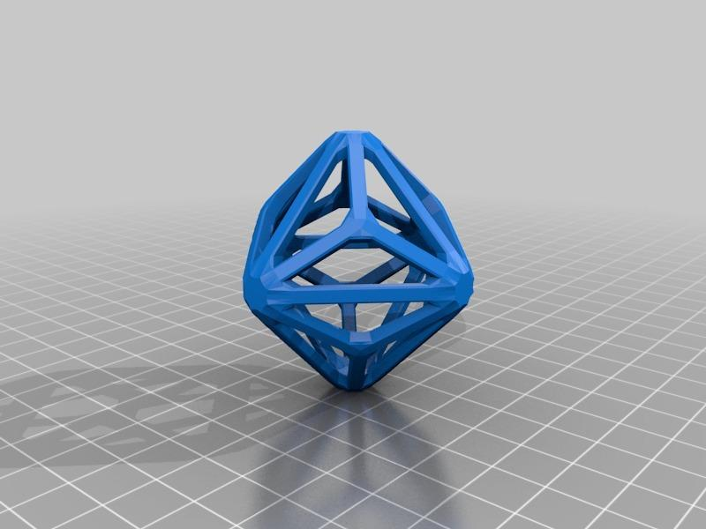
Triakis Octahedron
Catalan solid
<icon name="arrow-left-right" size="xl"/>
Duality
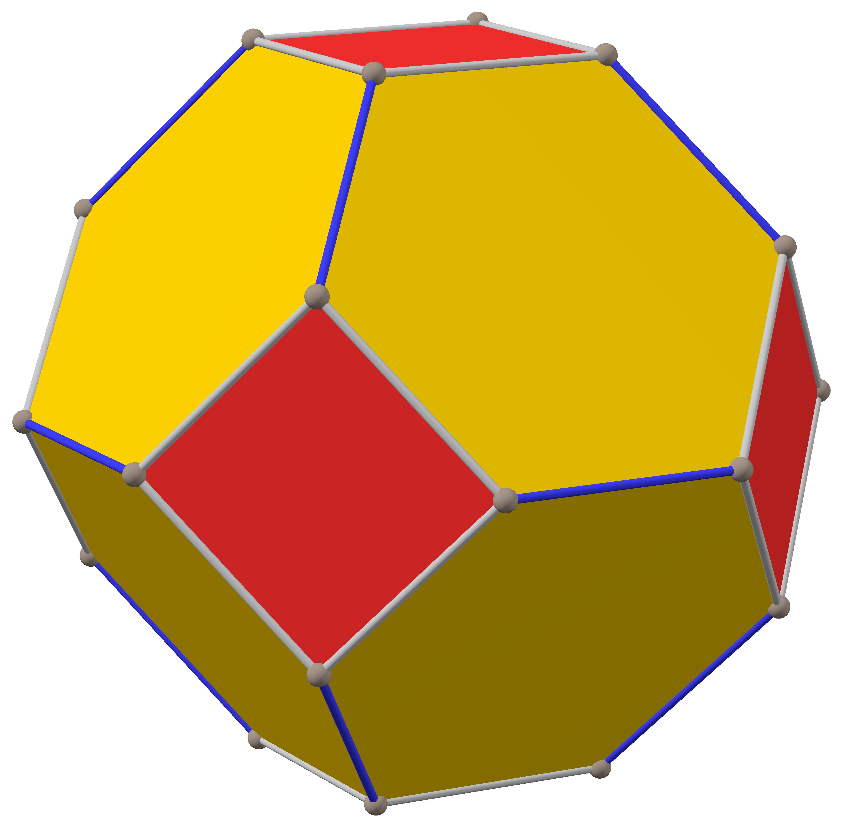
Truncated Cube
Archimedean solid
The Triakis Octahedron is the dual of the Truncated Cube.
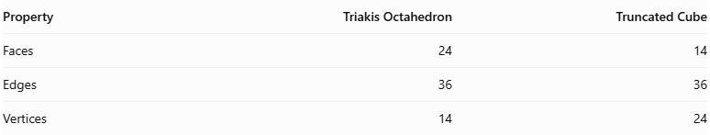
Property | Triakis Octahedron | Truncated Cube
Faces | 24 | 14
Edges | 36 | 36
Vertices | 14 | 24
In polyhedral duality:
- Each face of the Triakis Octahedron corresponds to a vertex of the Truncated Cube.
- Each vertex of the Triakis Octahedron corresponds to a face of the Truncated Cube.
- Their edges correspond to each other.

Construction of Triakis Octahedron

Geometric Instruments Used
# Source: AI Source: Provided by: [Data Path: Persons Table -> ID Column: 1, Name_En Column: Motasem Essam] -> From: [ChatGPT] on [7/25/2026]
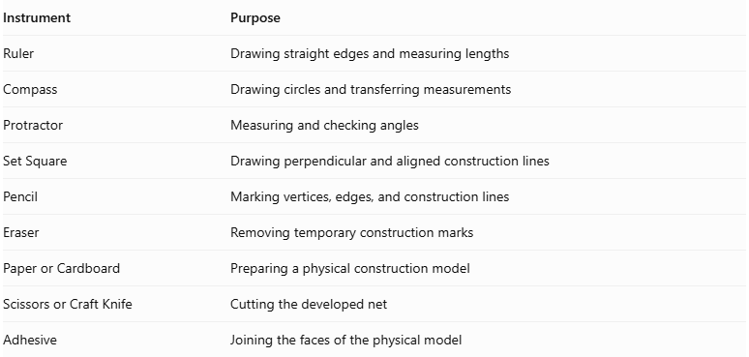
Instrument | Purpose
Ruler | Drawing straight edges and measuring lengths
Compass | Drawing circles and transferring measurements
Protractor | Measuring and checking angles
Set Square | Drawing perpendicular and aligned construction lines
Pencil | Marking vertices, edges, and construction lines
Eraser | Removing temporary construction marks
Paper or Cardboard | Preparing a physical construction model
Scissors or Craft Knife | Cutting the developed net
Adhesive | Joining the faces of the physical model

Instrument-Based Construction Procedures

Method 1: Construction Using a Regular Octahedron
# Source: AI Source: Provided by: [Data Path: Persons Table -> ID Column: 1, Name_En Column: Motasem Essam] -> From: [ChatGPT] on [7/25/2026]
Step 1: Construct the Central Octahedron
- Draw a regular octahedron using eight congruent equilateral triangular faces.
- Ensure that its six vertices and twelve edges are clearly marked.
- Use a ruler, compass, and protractor to maintain the required dimensions.
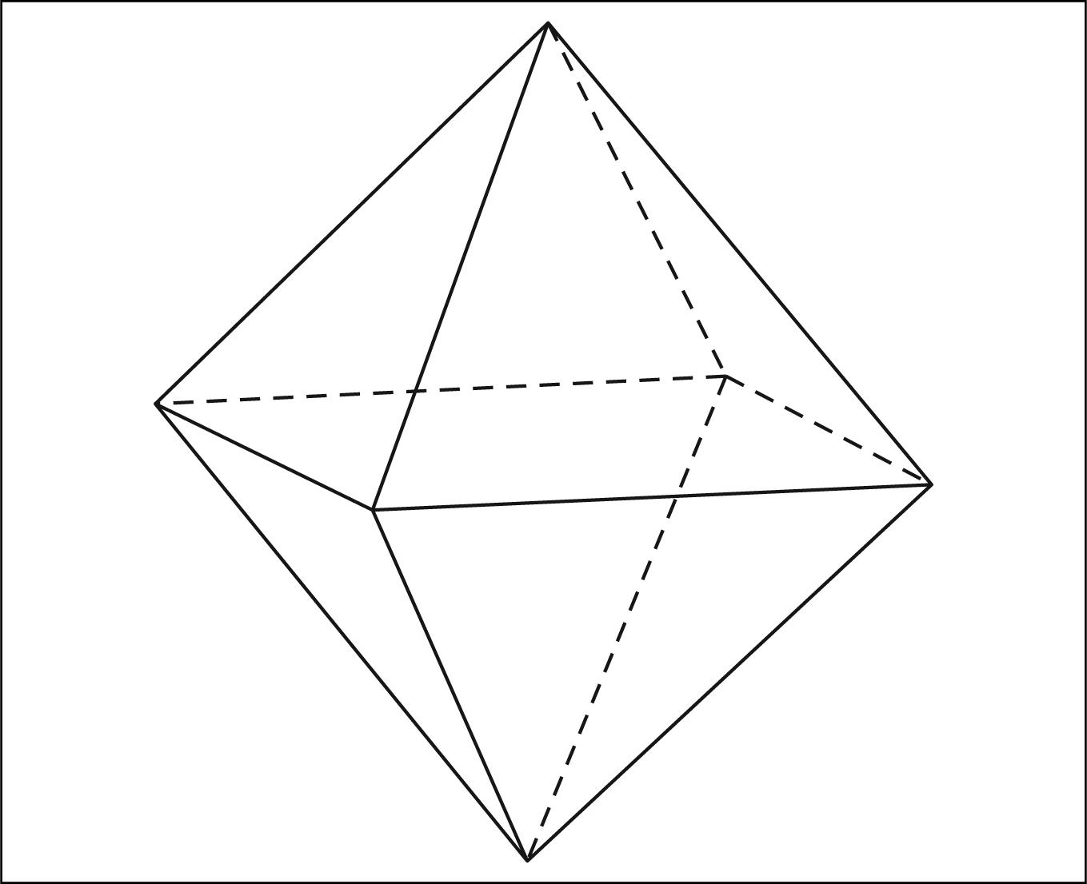
Step 2: Identify the Eight Triangular Faces
- Identify all eight triangular faces of the octahedron.
- Each face will serve as the base of an added triangular pyramid.
- Mark the center of each triangular face.
Step 3: Determine the Pyramid Dimensions
Let:
- $a$ = edge length of the central regular octahedron.
- $s$ = lateral edge length of each added pyramid.
- $h$ = perpendicular height of each pyramid.
For the standard Triakis Octahedron, the edge-length ratio is:
$$\frac{s}{a}=2-\sqrt{2}$$
Therefore:
$$s=(2-\sqrt{2})a$$
The pyramid height is:
$$h=\sqrt{s^{2}-\frac{a^{2}}{3}}$$
Or:
$$h=\frac{a}{3}\sqrt{51-36\sqrt{2}}$$
These dimensions produce the standard congruent triangular faces.
Step 4: Construct the First Triangular Pyramid
- Use the first octahedral face as the triangular base.
- Locate its center.
- Construct a perpendicular height of length $h$ from the center of the base.
- Mark the pyramid apex at the end of this height.
- Connect the apex to the three vertices of the triangular base.
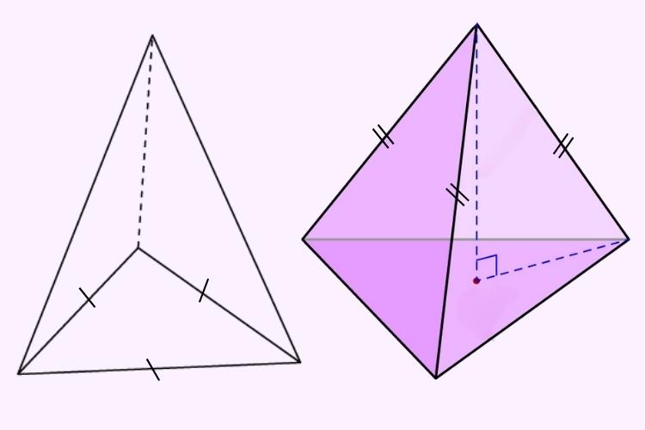
Step 5: Repeat on the Remaining Faces
- Construct an identical triangular pyramid on each of the remaining seven octahedral faces.
- Maintain the same lateral edge lengths and perpendicular heights.
- Ensure that the eight pyramids have matching dimensions.
Step 6: Join the Pyramidal Faces
- Connect each pyramid apex to the three vertices of its corresponding base.
- Treat the original octahedral faces as internal construction surfaces.
- Retain only the exposed triangular faces.
Step 7: Complete the Solid
- Remove or hide the internal octahedral faces from the final representation.
- Trace all 24 external triangular faces.
- Verify the 36 edges and 14 vertices.
- Check that all triangular faces are congruent.
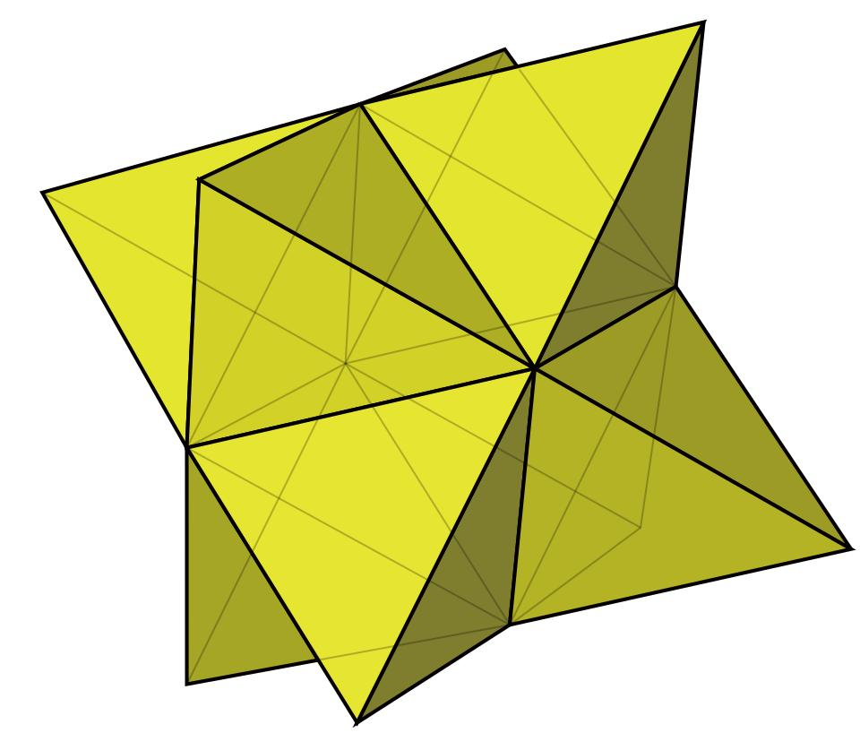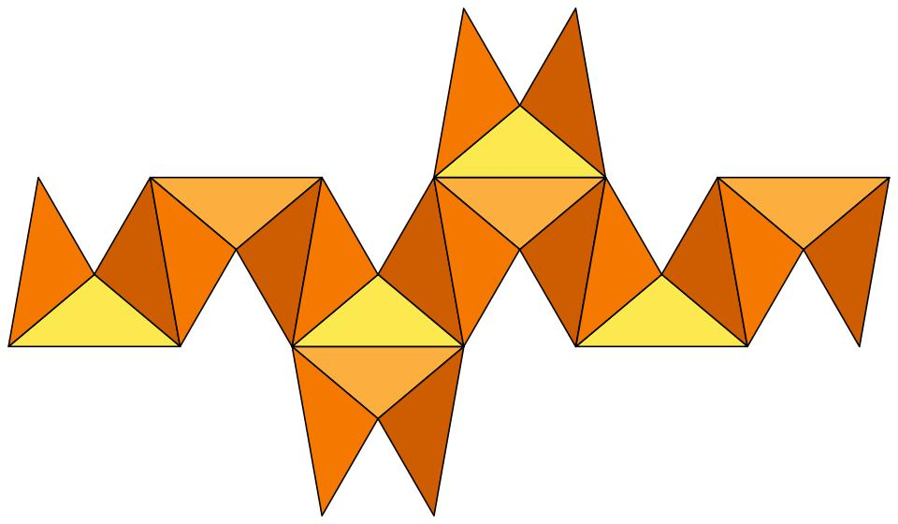

Method 2: Construction Using a Net
# Source: AI Source: Provided by: [Data Path: Persons Table -> ID Column: 1, Name_En Column: Motasem Essam] -> From: [ChatGPT] on [7/25/2026]
Step 1: Prepare a net containing 24 congruent isosceles triangles.
Step 2: Arrange the triangles according to the face adjacency of the Triakis Octahedron.
Step 3: Add small tabs along selected outer edges for joining.
Step 4: Cut out the net carefully.
Step 5: Fold along the shared edges to form the three-dimensional structure.
Step 6: Join the corresponding edges using adhesive.
Step 7: Check that the completed model has 24 faces, 36 edges, and 14 vertices.

Key Points
# Source: AI Source: Provided by: [Data Path: Persons Table -> ID Column: 1, Name_En Column: Motasem Essam] -> From: [ChatGPT] on [7/25/2026]
- The Triakis Octahedron is a Catalan solid.
- It is constructed from an octahedron with eight attached triangular pyramids.
- It has 24 congruent isosceles triangular faces.
- It has 36 edges and 14 vertices.
- Its edges consist of 24 shorter edges and 12 longer edges.
- Its vertices have two configurations: degree 3 and degree 8.
- It is the dual of the Truncated Cube.
- It has full octahedral symmetry $O_{h}$.
- It is convex and face-transitive.

Conclusion
# Source: AI Source: Provided by: [Data Path: Persons Table -> ID Column: 1, Name_En Column: Motasem Essam] -> From: [ChatGPT] on [7/25/2026]
The Triakis Octahedron is an important member of the Catalan solids family. Its distinctive structure is created by attaching eight triangular pyramids to a regular octahedron. Its 24 congruent triangular faces, two types of vertices, and dual relationship with the Truncated Cube make it an excellent example of polyhedral construction, symmetry, and geometric duality.

